La Crosse Symphony Fellowship for Underrepresented Musicians
The La Crosse Symphony Orchestra (LSO) is offering a one-year with an opportunity for a one-year Fellowship program for promising violinists and violists who are thirty-eight years old or younger pursuing an orchestral career. The LSO strongly encourages applicants from diverse backgrounds including but not limited to, diverse racial, ethnic, socio-economic, and geographic backgrounds that are traditionally under-represented in orchestras and whose participation will strengthen the LSO’s efforts to foster greater diversity, equity, and inclusion (DEI). Fellows will be paid at the principal rate ($75) to rehearse and perform with the orchestra. In addition, they will receive other career development benefits including mentoring and audition preparation, as well as Education/Community Engagement training with supervised experiences.

Fellowship Benefits:
- Fellows will be offered 26 services to rehearse and play with the full Orchestra on the six-season concerts and the Symphony for Youth concert.
- Fellows will gain valuable Education and Community Engagement opportunities by collaborating with area organizations during the 6 concert weeks. The Fellow will be compensated a service fee for each engagement with a minimum of 4 engagements:
  - Meet with the High School Orchestras of the La Crosse School District each concert week.
  - Gundersen Hospital engagement opportunities for music healing
  - Boys and Girls Club free violin lessons
  - Guest Artist Society event participation
- Fellows will be paid the LSO’s principal rate ($80) per service, travel costs up to $800 reimbursed for air fare/ driving costs / rental car fees, hotel stay or $69 per day for self-planned accommodations, and a per diem of $59 per day per the IRS Standard Rates for 2025. In addition, there will be a stipend of $100 per concert week such that the LSO Fellow will make at least $1000 per week they participate.
- Fellows will receive career development services throughout the program including:
  - Having a mentor from the LSO
  - Interview training and practice with an LSO member
  - Guidance from the LSO maestro

Eligibility Requirements:  - Enrollment in or graduation from a Graduate music program  - Thirty-eight years of age or younger as of January 1, 2025  Ideal Candidate Attributes:  - Desire to pursuing an orchestral career  - Passionate about Education and Community Engagement  - Experience teaching kids |  | Concert Week Schedule Outline:  Items to be scheduled during each concert week:  - To be scheduled in tandem with the Project Manager:  - Evening rehearsals – 7-10 pm on rehearsal days  - Daytime School visits  - Daytime Hospital performances  - Afternoon Boys and Girls Club violin lesson participation -Thursday from 3:30 to 4:30  - LSO regularly scheduled rehearsals/concerts:  - 26 services will be offered, 16 must be accepted.  Service dates for 2025-26:  Oct. 14,16, 17, 18 / Nov. 11, 13 ,14 ,15  Dec. 16, 18, 19, 20 / Mar. 10, 12, 13, 14  Apr. 7, 9, 10, 11 / Apr. 28, 30 May 1, 2  - Evening rehearsals/concerts (7 pm – 10 pm)  - Weekend concerts and 1 morning Youth Concert (Mar. 17, 18)

Application:
- Resume
- Up to 3 YouTube links of a SOLO performance

Application Process:
- Applications are due by Wednesday, April 9, 2025 at 11:59pm.
- Email your resume and YouTube performance links with the subject labeled as: LSO Fellowship Application Your First and Last Name to admin@lacrossesymphony.org.
- A committee will meet and decide which candidates will move on to the second round. Applicants will be notified no later than Wednesday, April 16, 2025.
- The second round includes a live audition with the audition committee and an interview via Zoom held on Saturday, May 03, 2025.

Audition Committee:

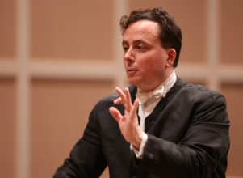 | Alexander Platt  Conductor of the La Crosse  Symphony Orchestra |  | Wes Luke  Concertmaster of the La Crosse Symphony Orchestra  Addition Role: Fellow Audition Coach
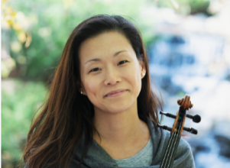 | Michelle Elliott  Associate Concertmaster of the  La Crosse Symphony Orchestra  Additional Role: Fellow Liaison | 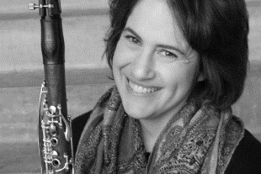 | Sarah Manasreh-Decker  Engaged Symphony Patron with a Music Education and Performance Degree
 | Aaron Schwartz  Assistant Concertmaster of the  La Crosse Symphony Orchestra  Additional Role: Fellow Mentor

